**.net application manual process**

* <https://docs.nopcommerce.com/en/installation-and-upgrading/installing-nopcommerce/installing-on-linux.html> for manual steps
* This application requires
  + mysql server (lets ignore this)
  + .dotnet runtime 7.0
  + it runs on port 5000
* Steps:
  + Ensure dotnet 7 is installed
  + Download application from <https://github.com/nopSolutions/nopCommerce/releases/download/release-4.60.2/nopCommerce_4.60.2_NoSource_linux_x64.zip>
  + unzip the application into some folder
  + create two directories bin and logs
  + Run the application using command dotnet --urls "http://0.0.0.0:5000" Nop.Web.dll

We have created the following Dockerfile

FROM mcr.microsoft.com/dotnet/sdk:7.0

LABEL author="khaja" organization="qt" project="learning"

ADD https://github.com/nopSolutions/nopCommerce/releases/download/release-4.60.2/nopCommerce_4.60.2_NoSource_linux_x64.zip /nop/nopCommerce_4.60.2_NoSource_linux_x64.zip

WORKDIR /nop

RUN apt update && apt install unzip -y && \

unzip /nop/nopCommerce_4.60.2_NoSource_linux_x64.zip && \

mkdir /nop/bin && mkdir /nop/logs

EXPOSE 5000

CMD [ "dotnet", "--urls", "http://0.0.0.0:5000", "Nop.Web.dll" ]

* This is not working  
  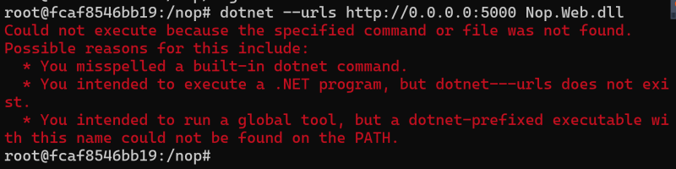
* Try fixing
* Try using alpine version of dotnet 7 for the same application

**Dockerfile instructions**

* WORKDIR: This instruction sets the working directory <https://docs.docker.com/engine/reference/builder/#workdir>

In context of a single subnet defined network:

**Network**: a range of IP addresses, the first of which is the network address and the last the broadcast address. The size of the network is determined by the network subnet mask.

**Host**: a device IP address not being the first (network) address or the last (broadcast) address of the network. For example, a /29 network has eight IP addresses, but only six of them are host addresses.

**Loopback**: a host address that provides device connectivity to a core server for device management. In my world, it's the address used to manage (configure/maintain) the device and make it serve it's use in a network (not to be confused with the device's actual function).[referred as localhost]

**Broadcast**: the last IP address in a network. All packets to this address goes to all host IP addresses in the network.